Docker Best Practices:
- Use Official Docker Image as Base Image
- Cleaner Dockerfile
- Official Docker Image
- Verified and already built with best practices
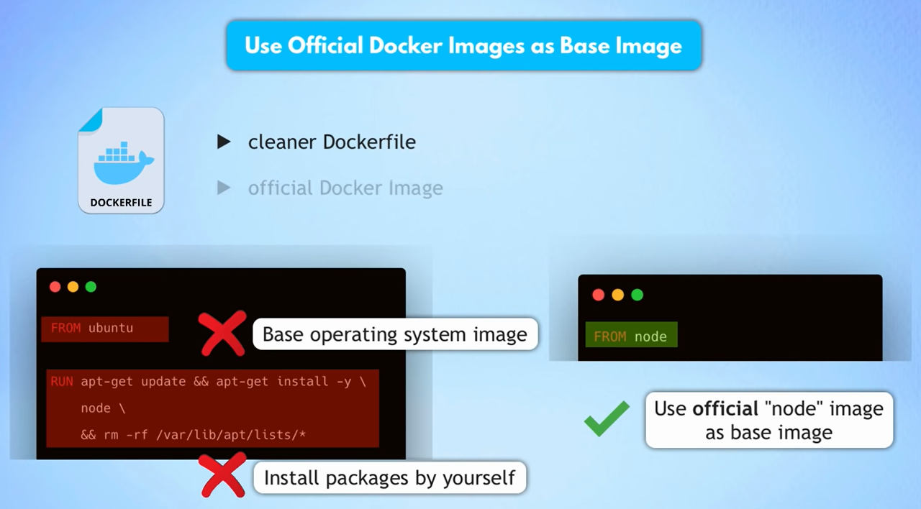
- Use specific Image tag
  - It will use the latest tag
  - FROM node => From node: latest
  - You might get different docker image versions
  - Might break stuff
  - Latest tag is unpredictable
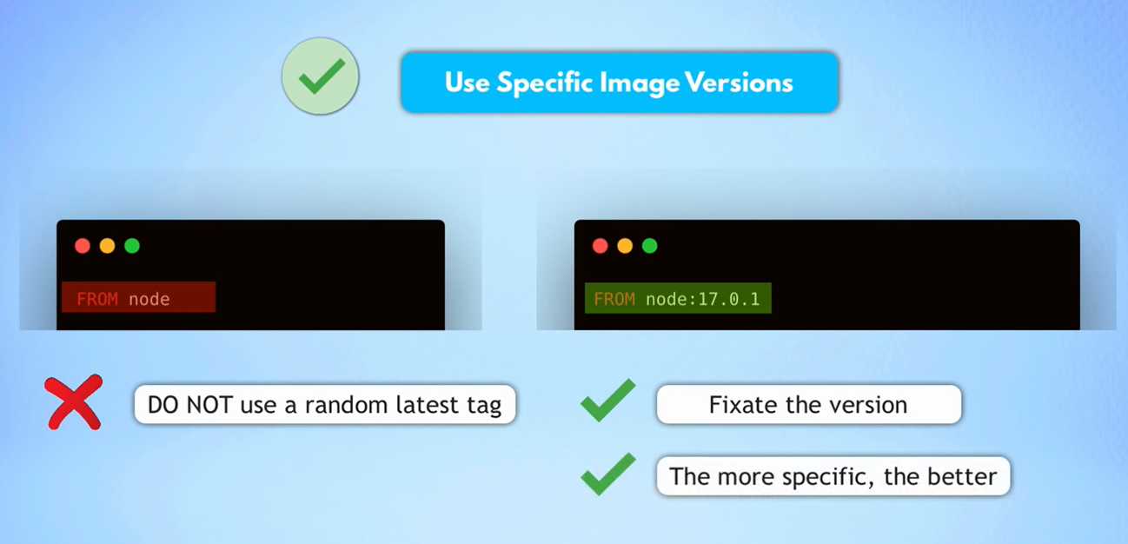
- Use Small-Sized Official Images
  - Smaller Images
  - Less storage spaces
  - Transfer Images faster
  - Minimize surface attacks
    - Larger Image Size
    - More security Vulnerabilities
    - Introduce unnecessary security issues from the beginning
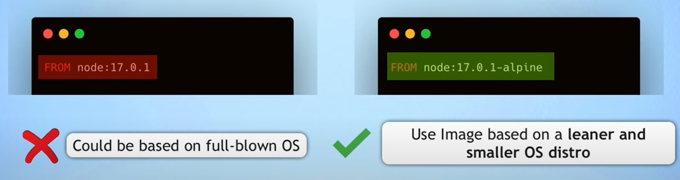
- Optimizing Caching Image Layers
  - docker image history <image id>
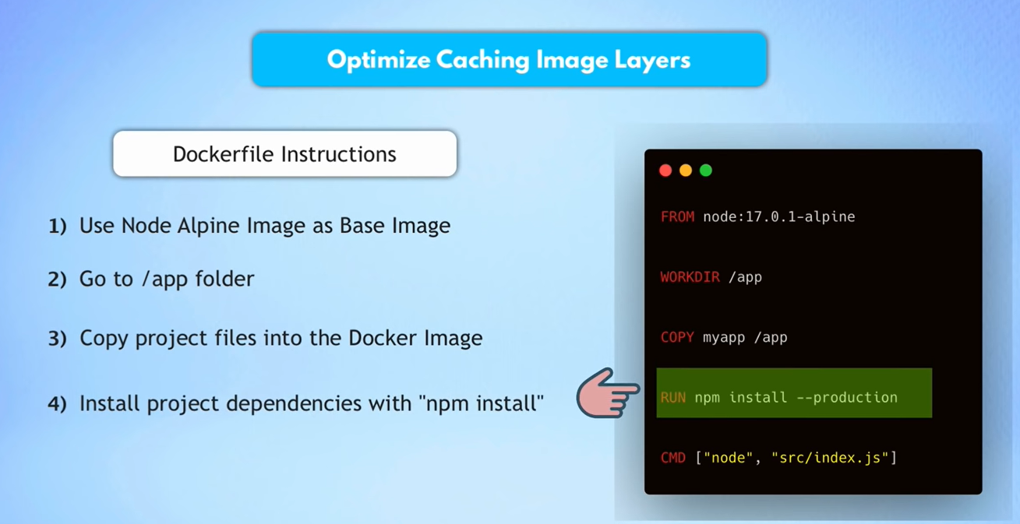
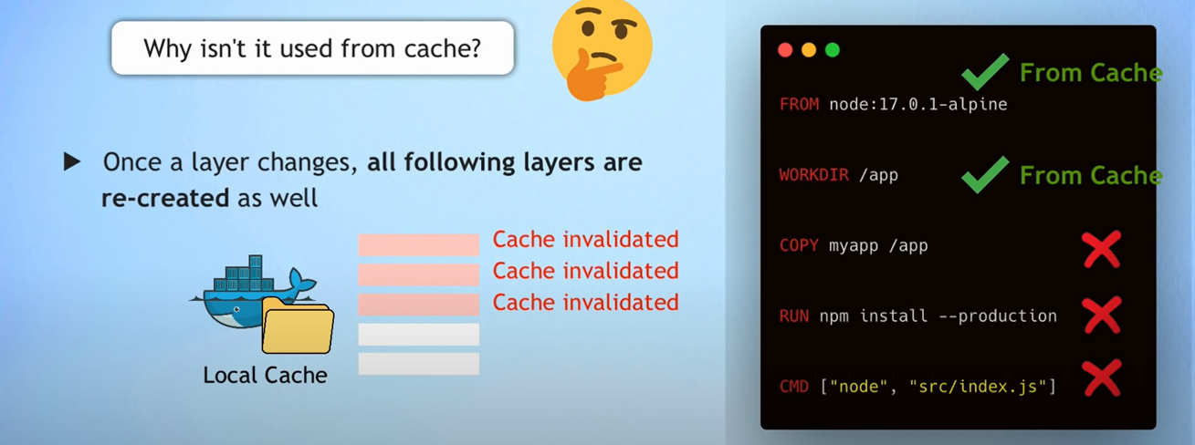
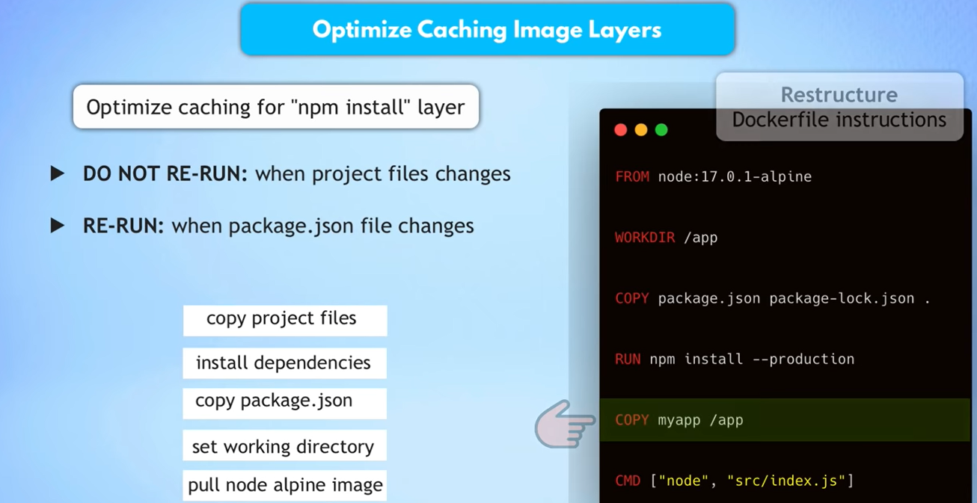
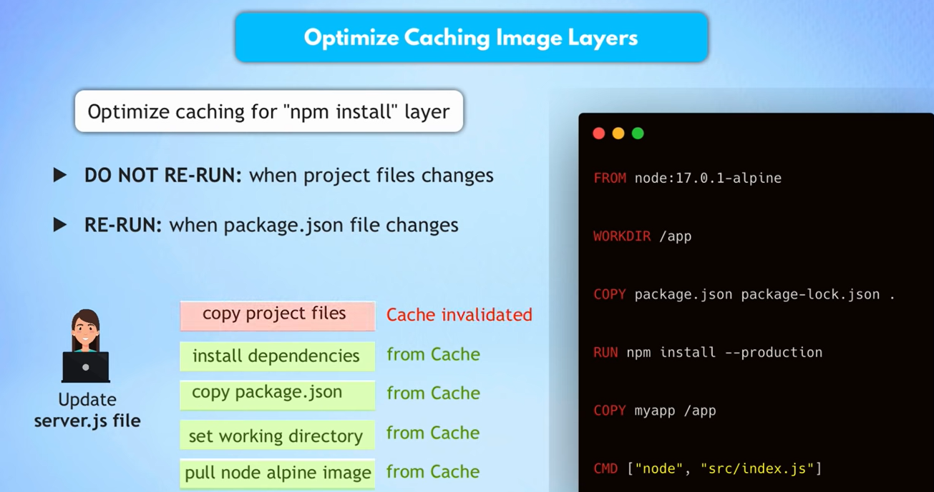
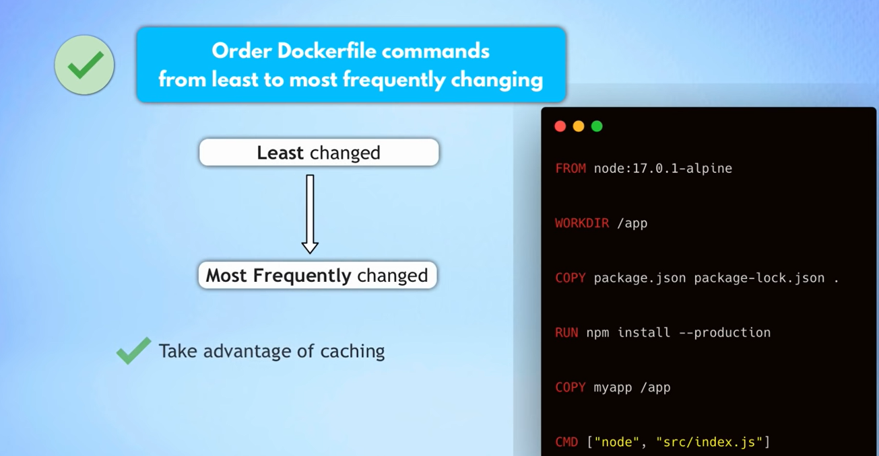
- Use .dockerignore to explicitly exclude files and folders
  - We don’t need everything inside the Docker image
  - Auto-generated folders (like target, build)
  - README.md
  - In Order to
    - Reduce Image Size
    - Prevent Unintended secrets exposure
    - Create .dockerignore file in the root directory
    - Ignore .git and .cache
- Make use of “multi-Stage” build
  - How do we exclude the build dependency from the final image?
  - Build Stage/ Runtime Stage

  - Contents, that you need for building the image. DON’T NEED them in the final image to run the app
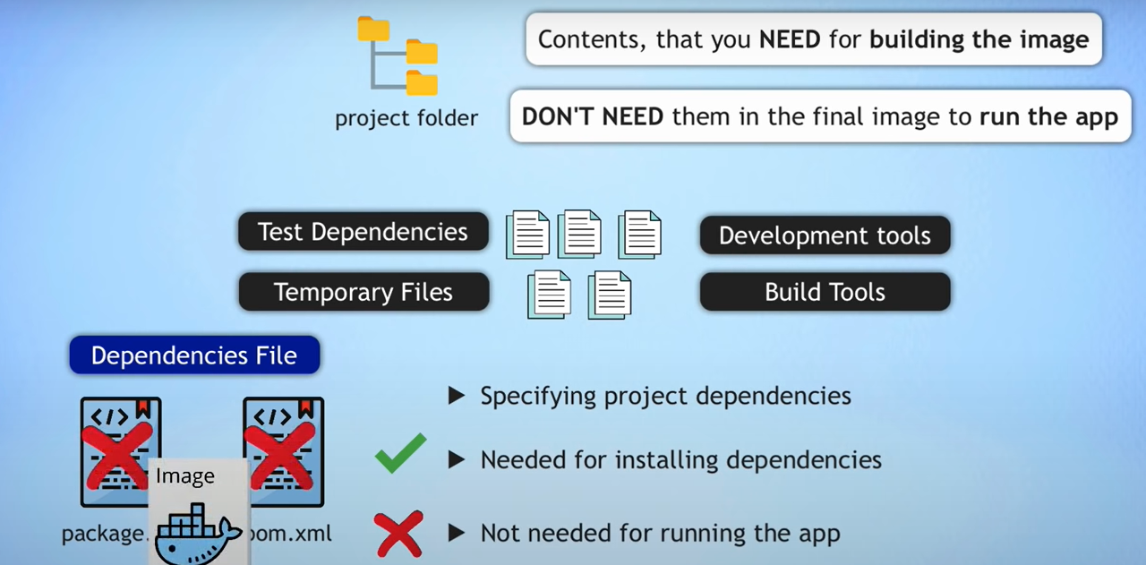
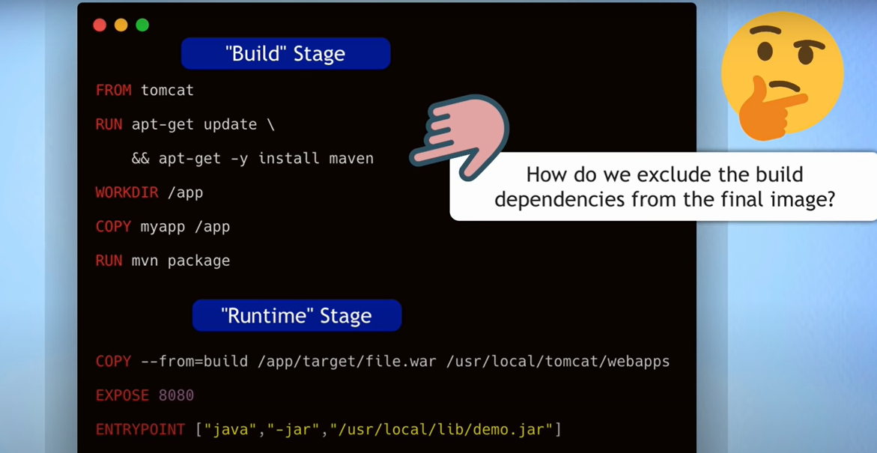
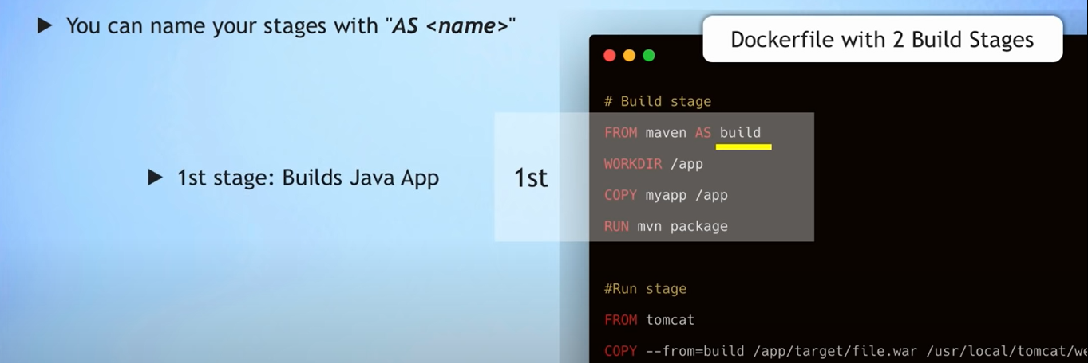
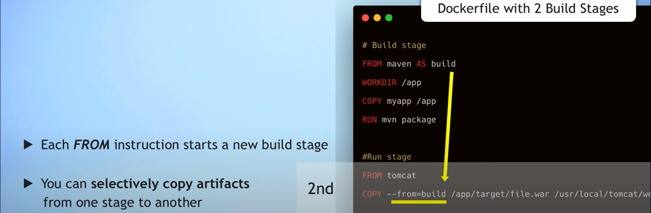
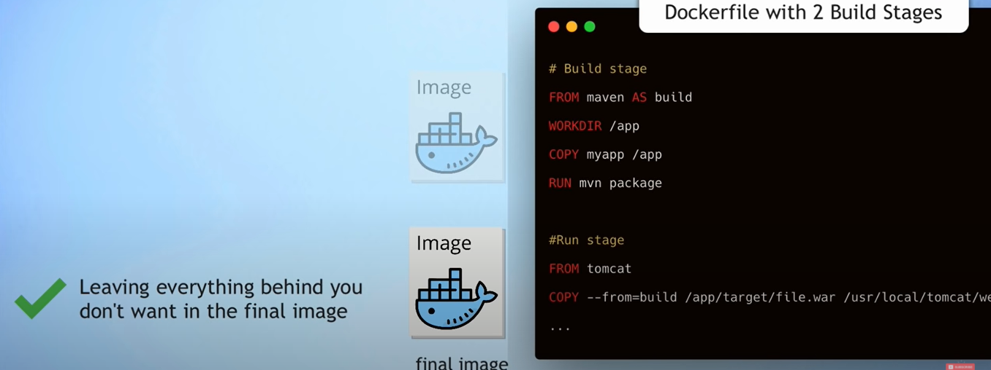

- Use the Least Privileged User
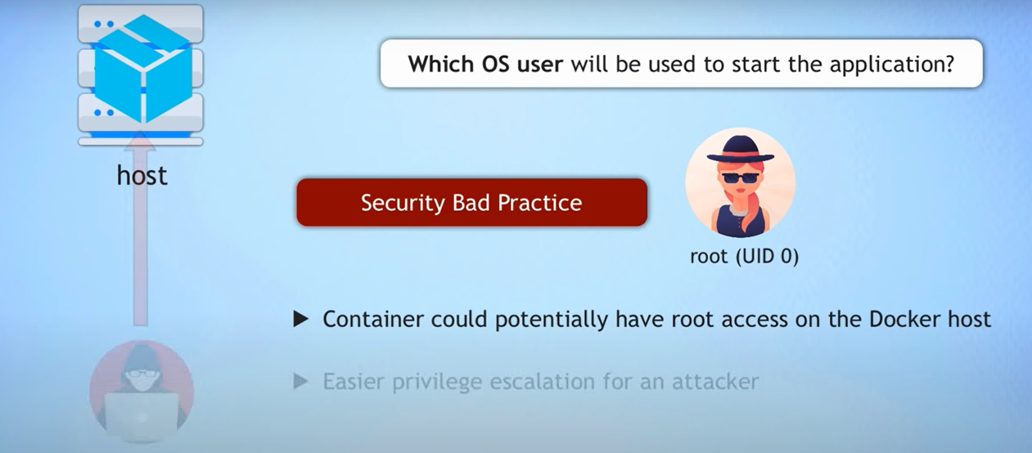

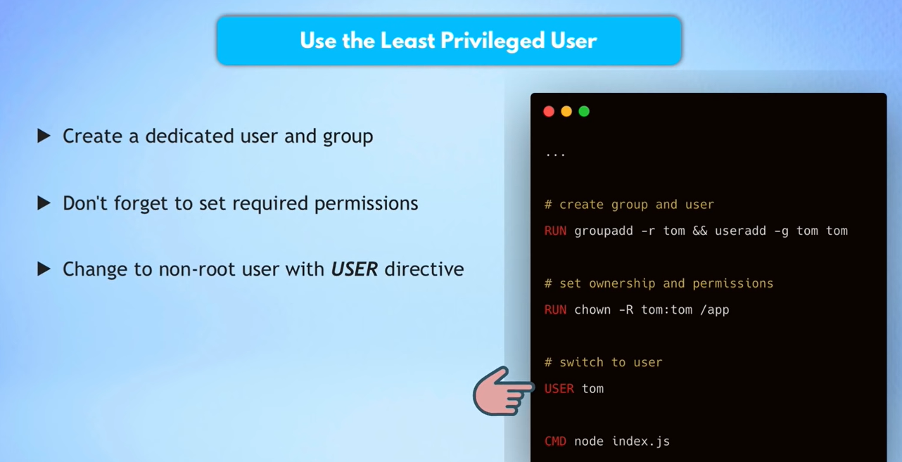
- Scan Your Image for Vulnerabilities using docker scan myapp:1.0
  - How to validate the built Image for security vulnerabilities?
  - Docker uses Snyk service for the vulnerability scan.
  - You can configure DockerHub, to scan the Image automatically when the image gets pushed to the Docker repo
  - Integrate in CI/CD

